
2015 PROGRAM
AD RATE SHEET

HONORING THE GIANTS OF SHORT FILM
TThe 2nd Annual Short Film Awards program booklet will be a 5” x 8”, color, commemorative booklet featuring our SOFIE Award Nominees. The programs will be distributed at the awards ceremony and also available at the post-awards celebration.

Additionally, all businesses that purchase an ad in the program booklet will also be featured during the awards ceremony, through onstage videos, signage and mentions. The event will be held in New York City and also live streamed across America and the world.

Business ads will also be posted on TSFA website and social media accounts within 48 hours of payment posting. Business ads will remain on the website and social media accounts through January 2016.

Deadline for artwork and payment is Monday, November 2, 2015.

100s of Entries + Over 40 Countries + 20 Categories + The 1 & Only SOFIE

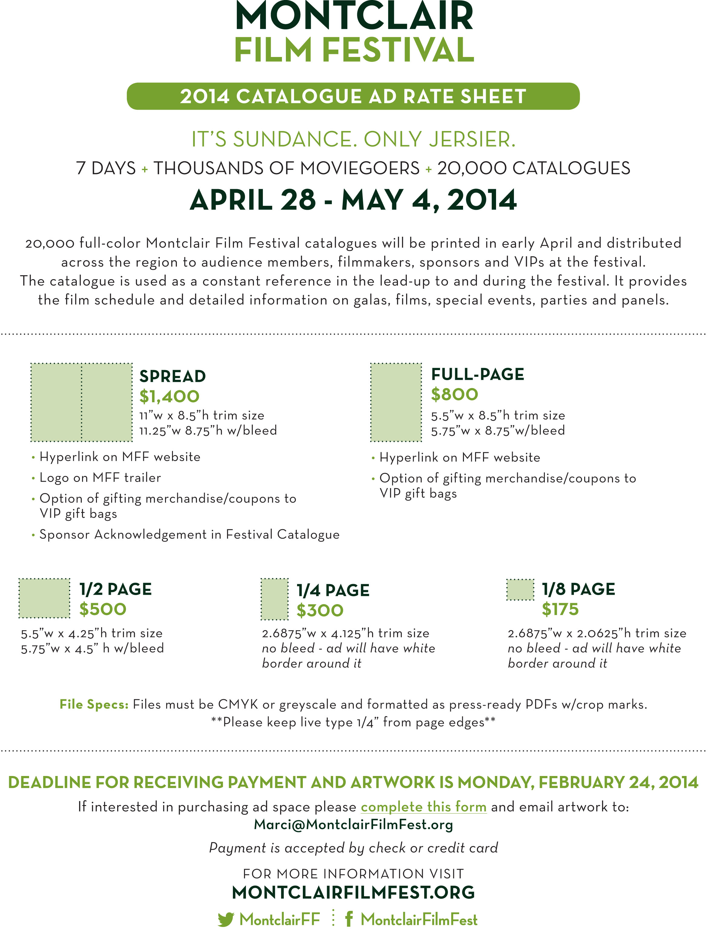
SPREAD: $500
11”w x 8.5”h trim size
11.25”w 8.75”h w/bleed

FULL PAGE: $100
5.5”w x 8.5”h trim size
5.75”w x 8.75”w/bleed

COVERS: $300
Inside Front and Inside Back
5.5”w x 8.5”h trim size
5.75”w x 8.75”w/bleed

Artwork Specs:
Files must be CMYK or Greyscale and formatted as press-ready PDFs w/crop marks.
**Please keep live type 1/4” from page edges**

1/2 PAGE: $50
5.5”w x 4.25”h trim size
5.75”w x 4.5”w/bleed

1/4 PAGE: $30
2.6875”w x 4.125”h trim size no bleed
5.75”w x 4.5” h w/bleed

Space is also available in the program on the SOFIE Shoutout pages, for special, personal messages to Nominees. 160 characters or less: $10

If interested in purchasing ad space, please print and complete this form or complete the form online at theshortfilmawards.com/advertise.php.

Payment is accepted by check or credit card.
CREDIT CARDS:
Through paypal.com

Send to email address:
info@theshortfilmawards.com

CHECKS:
The Short Film Awards
31 Vose Avenue
PO Box 962
South Orange, NJ 07079

Make payable to: The Short Film Awards

FOR MORE INFORMATION VISIT: theshortfilmawards.com
OR EMAIL: info@theshortfilmawards.com

@shortfilmawards  theshortfilmawards

CONTACT: _________________________________________________________________________

BUSINESS NAME: ____________________________________________________________________

ADDRESS: __________________________________________________________________________

PHONE: ___________________________________________________________________________

AD SIZE & RATE: ____________________________________________________________________

METHOD OF PAYMENT (CHECK OR CREDIT CARD): ________________________________________

SHOUTOUT PAGE MESSAGE: __________________________________________________________

SOFIE thanks YOU!!! Your support helps SOFIE to continue her mission on behalf of the most amazingly talented short filmmakers in the world!!!

